**17/04/16 Team Meeting**

**Updates:** What’d we get done this week?

-CAD finalized (for the time being), Technical drawings completed

-FEA Full modeling process started (Meeting with John/Ian) (Neil/Alex/Francesca)

-Further contact from Ian regarding analyzing buckling of composites (this is probably beyond the scope of this project), try to learn as much as we can about the weave, core, elastic modulus, & try to define the sandwich as a whole as opposed to each individual layer.

-Potential Sealant found (Per Russell)

<https://www.wrmeadows.com/poly-jet-lox-low-modulus-joint-sealant/>

-Chris is setting up a time w/ MELT to do PTFE laser cutting test

-Contacted Masterbond (adhesive is expensive), Jupyter notebook tutorial started/pushed to git,

-What Weldon accomplished this week: (started collecting eqns for stress analysis on flat plate end cap) (basically just prep work & some minor analysis at this point so far)

-Weldon has FE exam this week so some of this time will be committed to that

Part numbering convention:

####-A (first two digits are type of part, i.e. rings or end cap...etc, last two digits are iteration #)

Liner: 01 series Example: 0101 is first liner iteration, 0102 is second liner iteration

Rings: 02 series

End cap: 03 series

Al Tape: 04 series

PRV pipe: 05

Gasket: 06

Letters refer to various versions, such as tube liner vs sheet with seam liner

Example: 0201-A is ring designed for sheet liner iteration 1, 0201-B is ring designed for tube liner iteration 2.

A=Sheet liner, B=Tube liner

**Thoughts:**

-2nd iteration ring designs? Pretty good idea, let’s start to analyze for 2nd iteration of ring designs. This design would alleviate any Etching concerns as it could be accomplished with virgin PTFE + additional gasket.

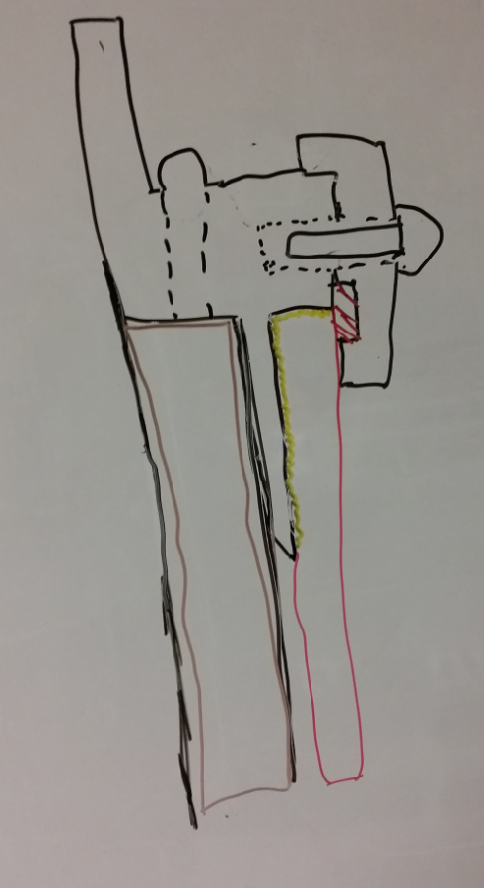 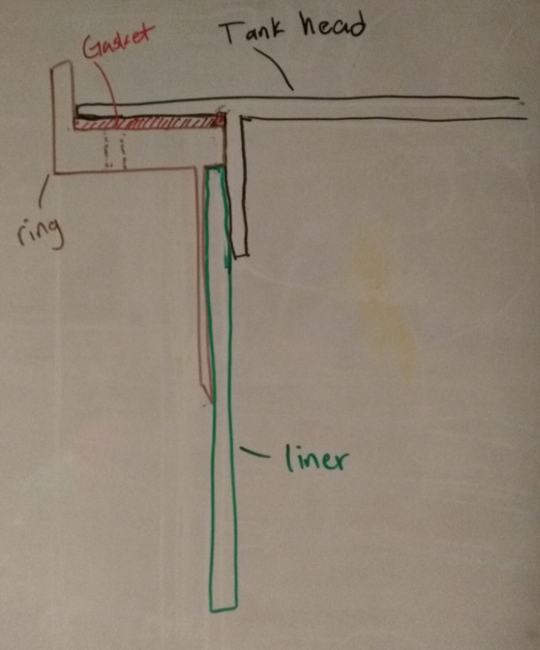

-How do we show a FS=2 empirically for this tank, or on sealant? We will have to break a lot of tanks….

-Previous teams’ book as a reference..(now around our work area) they did a TON of work on the airframe stuff, there is likely a lot of data we can simply reference to speed things along

-Focusing on the procedure being scalable is a good idea. Even though we do not know for certain what the scaled up model will be, we can just choose something arbitrary (aka 10”) so show that things will scale down the line.

**For next week: *(....) designation afterwards for my purposes only ~NB***

-Start researching LOX compatibility more thoroughly (pushed)

-Being FEA full modeling (Neil/Alex/Francesca?) (pushed)

-Order caulking/sealant/permabond this week (ig)

-Order some of those teflon bags to investigate if it will be feasible to include (ig)

-Send off designs/drawings to be machined (1 or 2 replicates?) to begin stage 1 prototyping. Stage 1 will help us develop the layup procedure for this tank (which is one of the major deliverables for PSAS) as well as providing us with burst test data. (Chris/Weldon) (ig)

-Drawings of 0201A and 0201B will be finalized before 5pm tomorrow (4/17) (Chris)(ig)

-We need to get our hands on LOX and start doing compatibility testing….developing testing procedures/what test? (Need to go to liquid test stand meetings since they are really close to getting some LOX)(If nothing else, let’s get regular contact with them to make sure they can order enough for us to be able to use) (pushed)

-coupled with obtaining LOX, we need to develop what tests we want to do with it, as well as procedures/safety etc regarding LOX testing….(pushed)

-worried about LOX ignition, and oxidation

-Testing etched surface in contact with LOX to see if there is any chemical incompatibility

-Further refine heat transfer analysis (Alex/Russell)(pushed)

-Prelim gasket stress analysis (Russell is waiting on that gasket book, won’t be here for another 5 days or so) (Russell)(solved)

-For all analysis, start moving towards converting to Jupyter Notebook (per Francescas tutorial stuff on git/drive)

-Chris is setting up time w/ MELT for PTFE test laser cutting, as well investigating what scrap acrylic is around for cutting templates. If nothing else, can go to TAP plastics and just buy some(pushed)

-Consider using keg ball-lock connector/fitting, keep on back burner for now we will investigate more later (pushed)

-Schedule another LN2 testing time for perform further tests (pushed)

-Literature research party, literary research for composite material

-Start experimental lab write up documentation procedure(from last weeks list)(pushed)

-Spray on chemical insulation research (from last weeks list)(pushed)

-Convert all of these ‘tasks’ to the issues tab on Git, & keep converting everything to Git (Neil)(done)

-Potentially start working on 2nd iteration ring/endcap design (Russell)(pushed)

-Are there any additional things we need to consider/develop for hydrotesting?

**Task focus:**

Russell- Ht xfer/gasket analysis, then CAD (pushed)

Alex- Ordering, Heat xfer refinement (pushed)

Weldon-Stress analysis started last week (FE is on wed, so likely will not be accomplished until wed/thurs) (pushed)

Chris-Finish drawings/get sent off, get MELT stuff arranged (pushed)

Francesca-LOX compatibility research/cals, transport theory (pushed)

Neil- Git, get FEA started, manage stuff, help out with analysis etc (pushed)